# GRAPHIC DESIGNING

An Internship Project Report Submitted in partial fulfilment of the requirements for the award of the degree of

# MASTER OF DATA SCIENCE

Submitted by

1. **JENIFER**

**REGISTER NO: P22DS009**



# PG DEPARTMENT OF DATA SCIENCE HOLY CROSS COLLEGE (AUTONOMOUS)

AFFILIATED TO BHARATHIDASAN UNIVERSITY

NATIONALLY ACCREDITED (4th CYCLE) WITH ‘A++’ GRADE (CGPA 3.75/4) BY NACC COLLEGE WITH POTENTIAL FOR EXCELLENCE TIRUCHIRAPPALLI-620 002, TAMIL NADU, INDIA

OCTOBER 2023

# PG DEPARTMENT OF DATA SCIENCE HOLY CROSS COLLEGE (AUTONOMOUS)

AFFILIATED TO BHARATHIDASAN UNIVERSITY

NATIONALLY ACCREDITED (4th CYCLE) WITH ‘A++’ GRADE (CGPA 3.75/4) BY NACC COLLEGE WITH POTENTIAL FOR EXCELLENCE

TIRUCHIRAPPALLI-620 002, TAMIL NADU, INDIA

# BONAFIDE CERTIFICATE

This is to certify that the Internship Project Work entitled **“Graphic Designing”** is the Bonafide Record of work done by

**NAME :** A. JENIFER

**REG NO:** P22DS009

In partial fulfilment of the requirements for the degree of **MASTER OF**

**DATA SCIENCE** during the academic year 2022-2023.

Class Teacher Head of the Department

Submitted for the Viva-Voce Examination held on _

# INTERNAL EXAMINER EXTERNAL EXAMINER

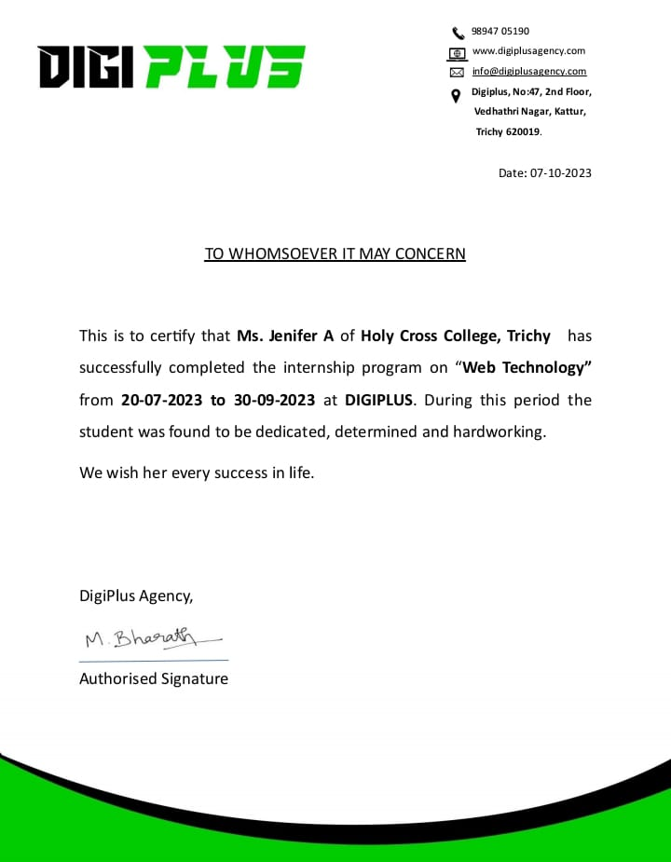

**INTERNSHIP REPORT**

# NAME : A. JENIFER

1. **CLASS : II-M.Sc. DATA SCIENCE**

# COMPANY : DIGIPLUS

A MARKETING AGENCY,

FIRST FLOOR, 47,

PAPPAKURICHI KATTUR,

TIRUCHIRAPPALLI,

TAMIL NADU-620019.

# TIMING : 3.00 PM TO 6:00 PM.

1. **DURATION : 2 MONTHS**

# 

**TABLE OF CONTENT**

|  |  |  |
| --- | --- | --- |
| **S.NO** | **TITLE** | **PAGE NO** |
| **I** | ABSTRACT | 1 |
| **II** | INTRODUCTION | 2 |
| **III** | AIM | 3 |
| **IV** | PLATFORMS AND USAGES | 3 |
| **V** | INTERNSHIP TASKS AND PROJECTS | 12 |
| **VI** | CONTRIBUTIONS AND ACCOMPLISHMENTS | 17 |
| **VII** | CONCLUSION | 18 |

# ABSTRACT

This report encapsulates my enriching journey as a graphic design intern at the marketing agency Digi Plus. As a fervent design enthusiast, this internship presented a profound opportunity to bridge the divide between theory and practical application, refine my creative abilities, and evolve into a proficient graphic designer. Throughout my internship, I thrived in a dynamic environment that fostered creativity, engaging in diverse design projects encompassing branding, marketing, and user interface design. This report delves into the details of these projects, outlining my roles, contributions, and the design principles I applied. It also underscores the technical competencies I honed during this period, including proficiency in industry-standard design software like Adobe Creative Suite. Furthermore, it underscores my progress in time management, collaborative teamwork, and adaptability, emphasizing the vital soft skills that I cultivated during my internship journey. An integral component of this report explores the synergy between my academic studies and practical experience, demonstrating how classroom theories and concepts seamlessly intertwined with real-world design challenges. This fusion of knowledge not only bolstered my creative problem-solving skills but also reaffirmed my dedication to pursuing a career in graphic design.

1

# Graphic Designing

**II. INTRODUCTION**

## The dynamic and ever-changing area of graphic design lies at the nexus of communication and creativity. I embarked on a journey as a graphic design intern at the marketing firm Digi Plus, which allowed me to learn more about this fascinating field and close the gap between theory and reality. This internship gave me priceless insight into the intricacies of visual communication, marking a significant turning point in both my academic and professional development.

## Company:

## The renowned marketing office operator, Digi plus, is known for consistently pushing the limits of design advancements. In addition to expanding my knowledge of graphic design, my work with this esteemed organization allowed me to observe firsthand how design can turn ideas into gripping visual narratives.

## Purpose:

The main purpose of this internship was to give me practical experience that would complement and strengthen my academic foundation in graphic design. It was designed to expose me to the practical aspects of the industry, instilling in me the ability to adapt to the demands of real design projects and equip me with skills that transcend the classroom.

# Journey:

I had the good fortune to work on a wide range of projects during my internship, each of which presented a different set of design challenges. Among the projects were [marketing designs, logos, wishes posters, etc.].

I got the chance to contribute creatively, work with knowledgeable design experts on each project, and witness directly the transforming impact of design.

# Learning curve:

The pinnacle of my internship experiences is this report. We shall study the intricacies, enhanced proficiencies, and insights gained from the projects I carried out in it. This demonstrates the personal and professional progress that took place throughout the internship for the designer.

2

# III. AIM

# Highlighting the impact of the internship experience on future career objectives in graphic design, reflect on personal and professional progress, and present the practical skills and insights gained during the internship, bridging the gap between academic knowledge and real-world application.

# IV. PLATFORMS AND USAGES

**Canva :**

# Canva is an easy-to-use online graphic design tool that can be accessed via any web browser. Well-known for being straightforward and simple to use, it's a preferred option for people and companies who wish to swiftly generate a range of design materials without requiring a significant learning curve. A vast selection of templates for flyers, presentations, posters, social media images, and other materials are available on Canva. For individuals who lack advanced design skills and wish to generate visually appealing content, it's an excellent option for novices. Canva is an adaptable web-based graphic design platform that offers users resources and tools to produce many kinds of visual material, including

# Posters and Templates:

**Poster and Template design in canvas:**

# With Canvas, making posters is an easy procedure that lets users make visually appealing designs for communicating information or promoting events. This is the method for drawing a poster on canvas.

# Choose a poster or template:

First, choose the suitable poster from Canva's large collection of pre-sized templates. Numerous possibilities are available to you, such as custom measurements or common poster sizes.

# Choose a template or start from scratch:

Canva offers a wide range of professionally designed poster templates for different situations and topics. Alternatively, you can start with a blank canvas to create a poster from scratch.

3

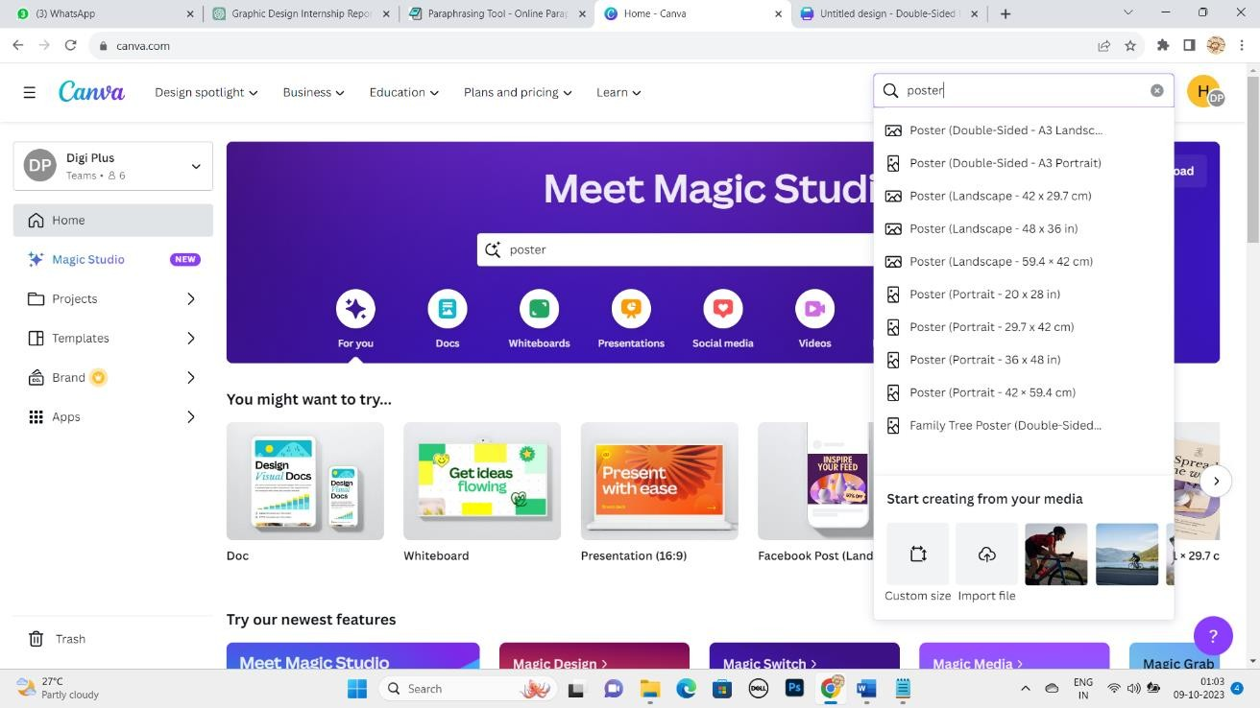

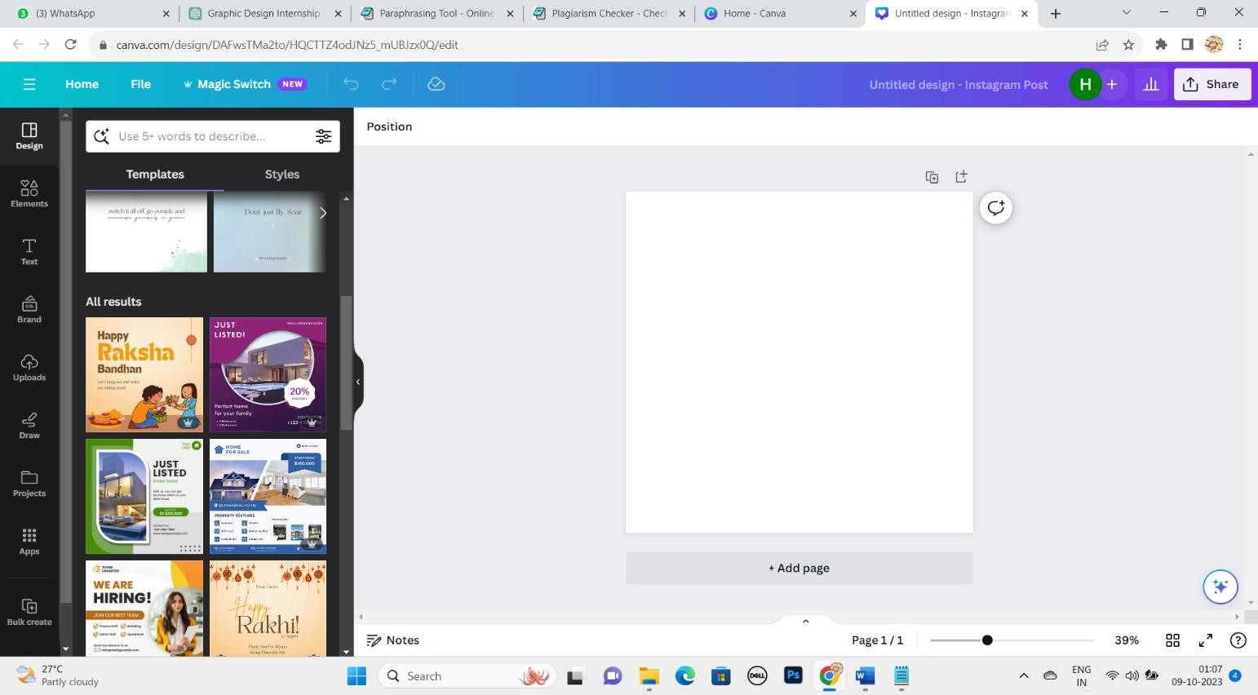

4

# Design Elements:

Customize your message by adding text, images, illustrations, icons and graphics from Canva's extensive media library, and upload your own images and graphics too.

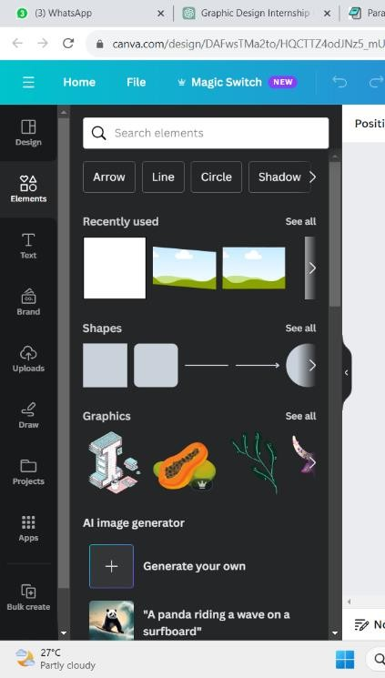

# Typography:

Experiment with different fonts, fonts, colors and styles to create interesting and readable text elements on your post. It also offers a wide variety of font styles.

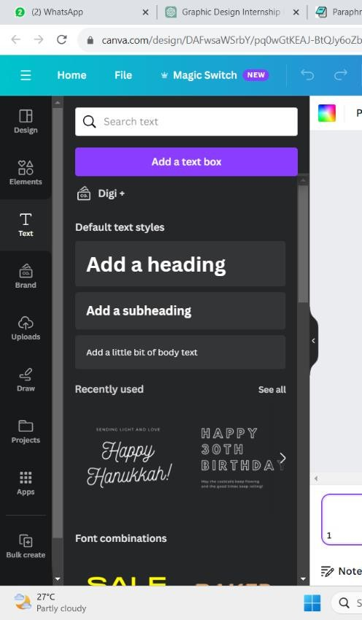

5

# Color palette:

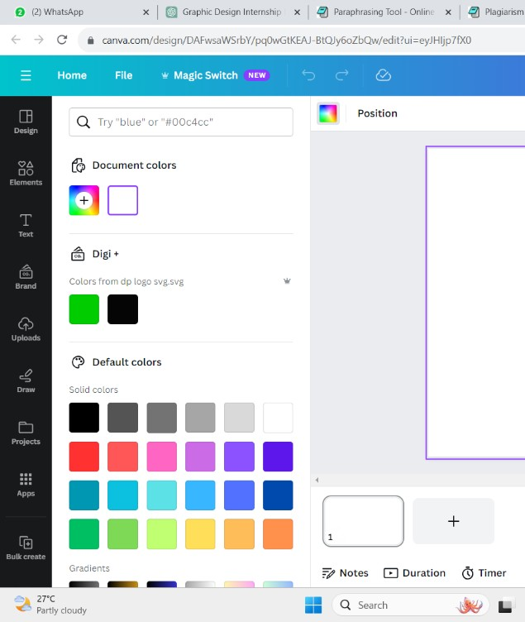Use Canva's color palette to create a harmonious and visually appealing color scheme for your post. You can also enter specific color codes that match your brand or theme.

# Layout and Composition:

Arrange design elements using Canva's drag-and-drop interface for a balanced and visually pleasing layout. Use grids and controls to precisely align elements.

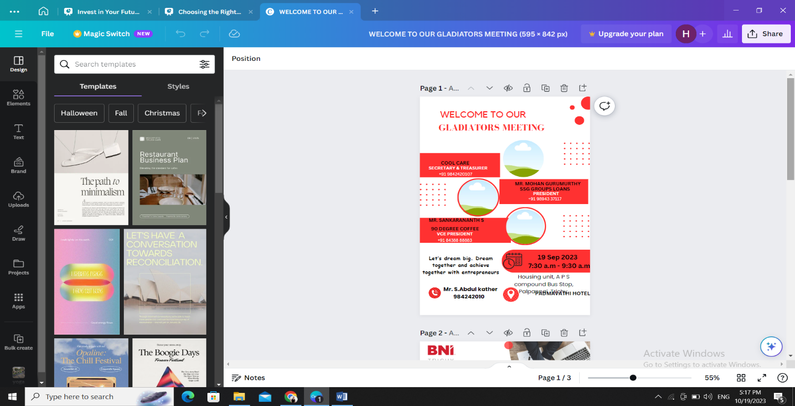

6

# Background and Effects:

Customize the background of the post with colors, gradients, textures or images. Add filters and effects to enhance the overall look and feel.

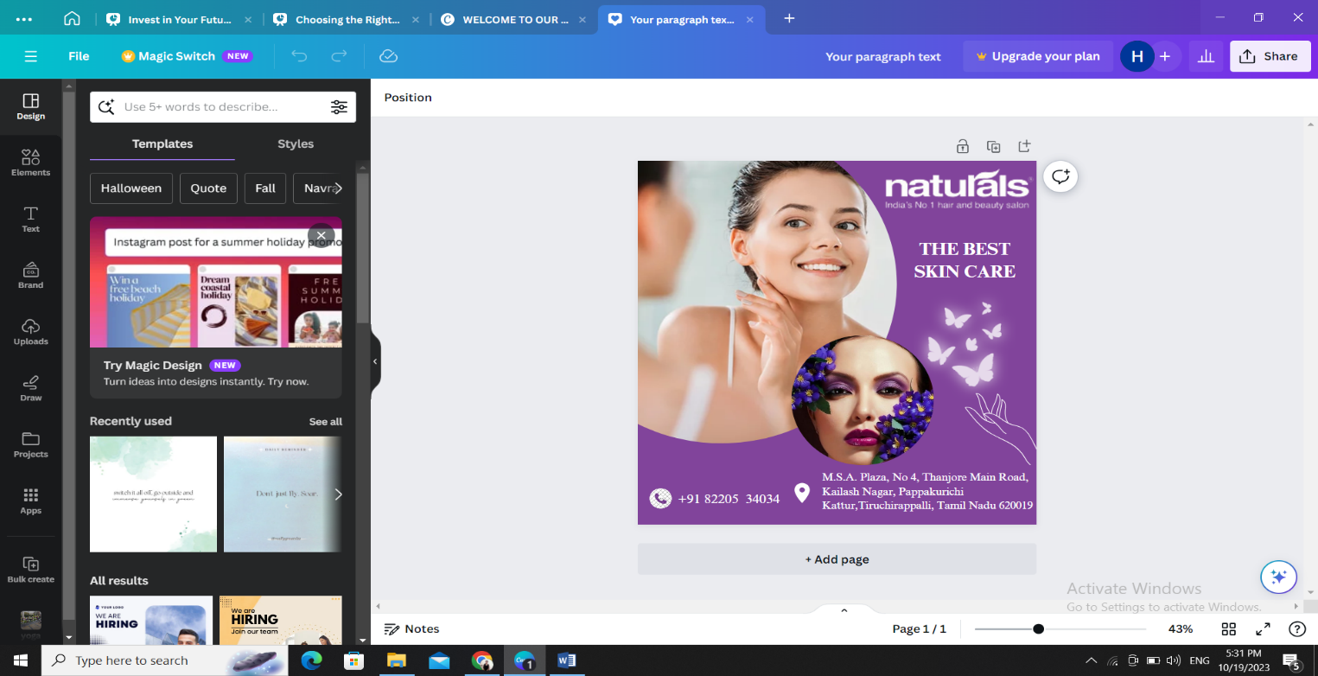

# Export or share:

When your post is ready, you can export it in different formats (such as JPEG or PNG) and choose the resolution. You can also share your designs directly from Canvas or collaborate with team members.

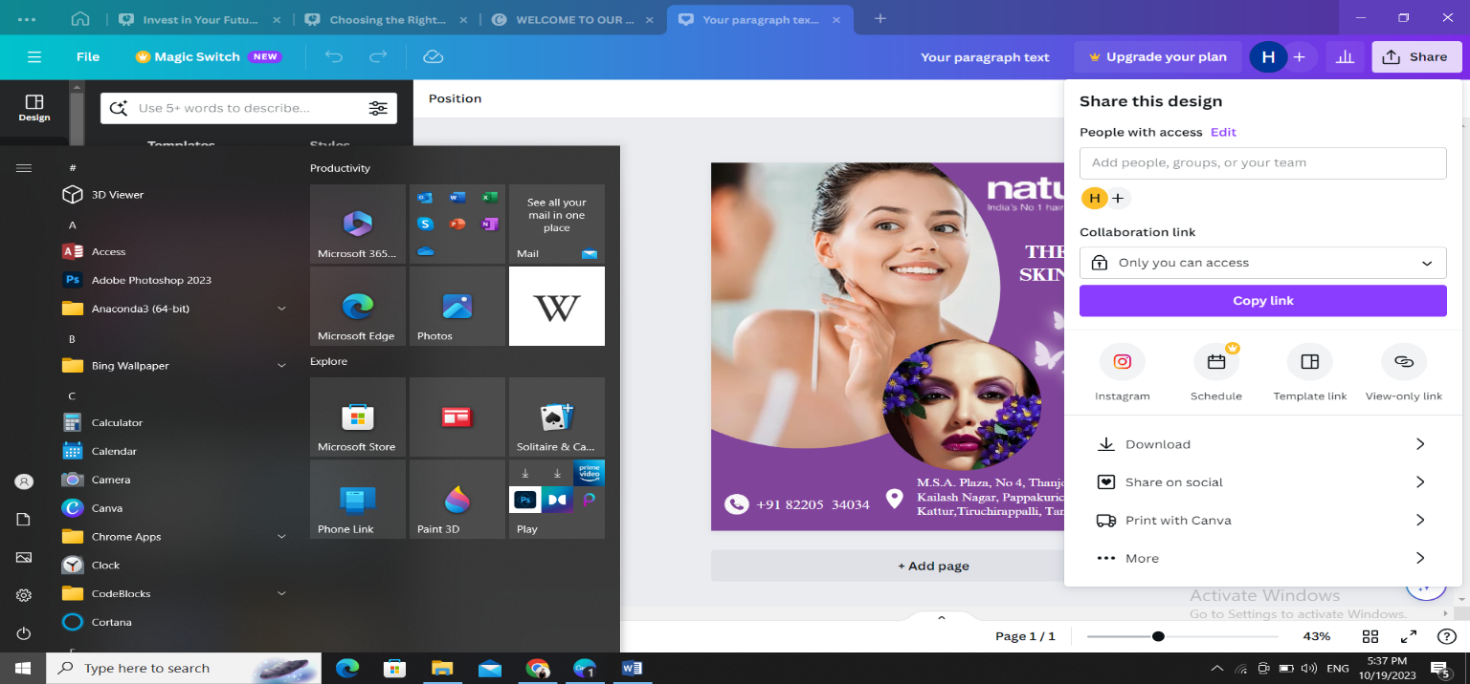

7

**Adobe Photoshop (PS):**

Adobe Photoshop is a professional image editing and graphic design software. It offers extensive tools and functions to manipulate images, create complex graphic designs and manage different file formats. Graphic designers, photographers, and other creative professionals use Photoshop extensively for photo retouching, digital painting, logo creation, and marketing materials. It offers high control and accuracy, but has a steeper learning curve than Canva Adobe Photoshop is powerful graphic design software, including creating posters and templates. Here is an explanation of how to use Photoshop to design your poster and templates.

# Poster and Template design in Photo Shop:

**Create a new document:**

Open Photoshop and create a new document with the desired dimensions for the poster. Set the resolution and color mode (usually CMYK for print and RGB for digital).

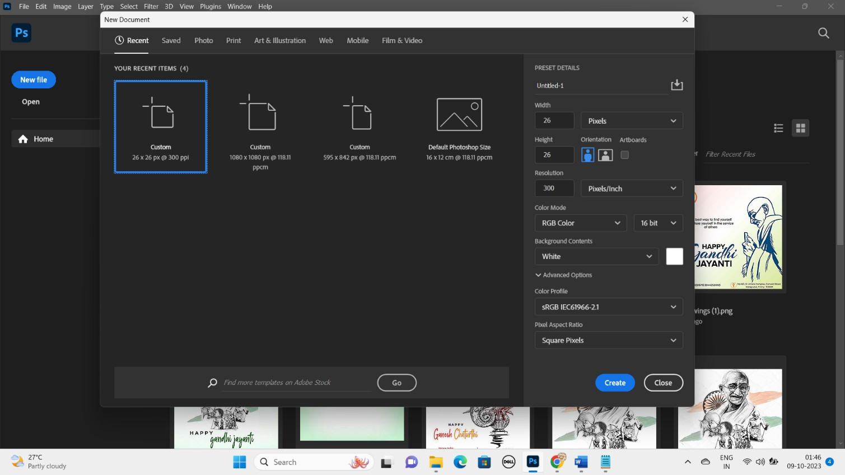

8

# Design Elements:

Start adding design elements to your post. You can import images, create shapes, use brushes and add text. Photoshop offers extensive design tools for precise control of every detail.

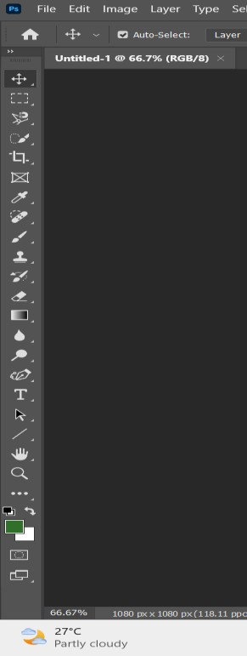

# Image editing:

If you use photos, Photoshop offers powerful image editing features. You can adjust colors, contrast and use various filters and effects to enhance your images.

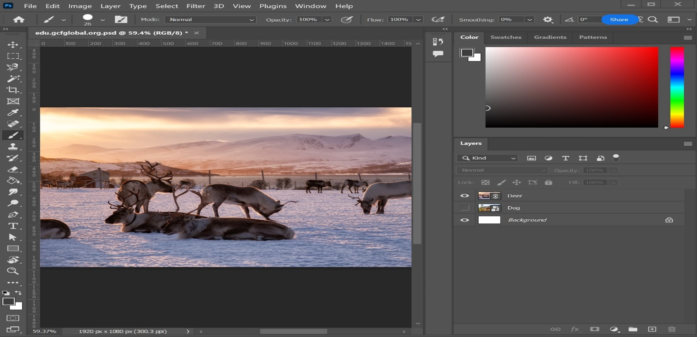

9

# Text and Typography:

Add text to your post using the Text tool. Edit fonts, sizes, colors and styles to create attractive typography. Use a layer style for text effects like shadows and outlines.

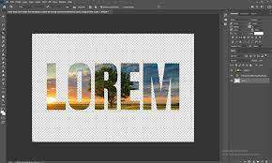

# Layers:

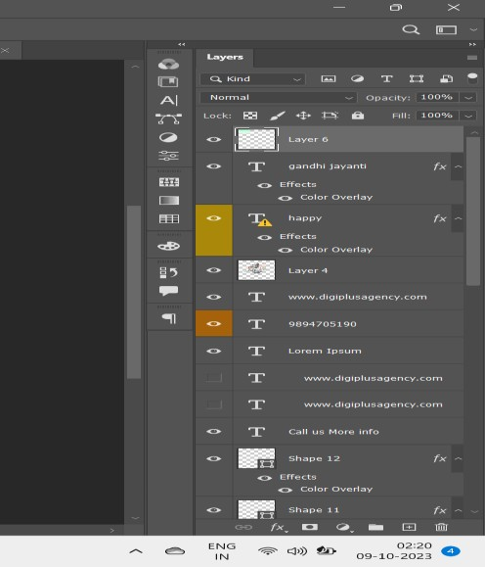Use layers to organize design elements. Each layer can contain different parts of the design, allowing you to work with them separately and make effects or adjustments.

10

# Color management:

Use the color picker to select and manage colors. Photoshop also supports color profiles and color swatches to ensure consistency in print or digital designs.

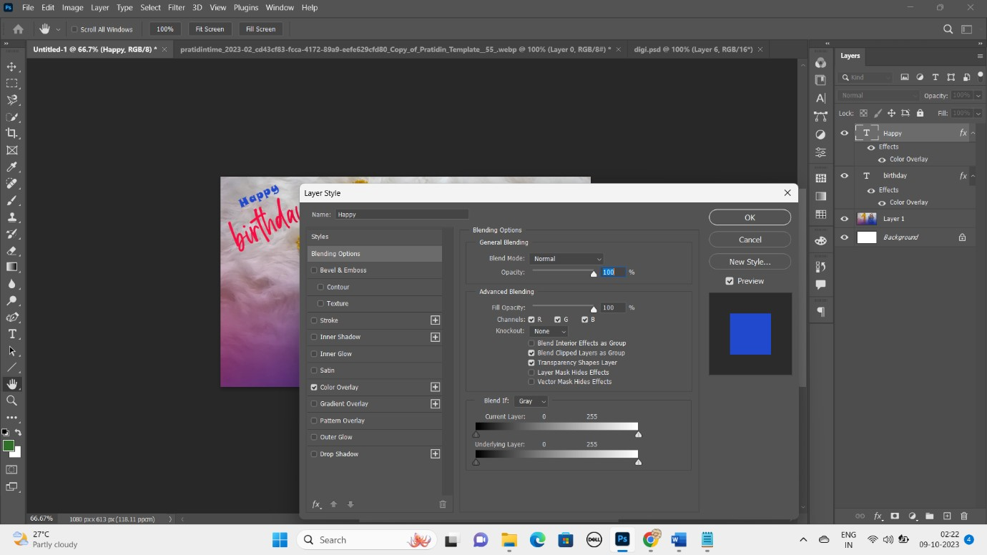

# Export or save:

When the post is ready, save it in the format of your choice (such as PSD for further editing or JPEG/PNG for sharing or printing). Adjust the resolution and quality settings.

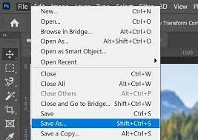

11

# V. INTERNSHIP TASKS AND PROJECTS

**TASK 1:**

Create a wishes poster for their clients:

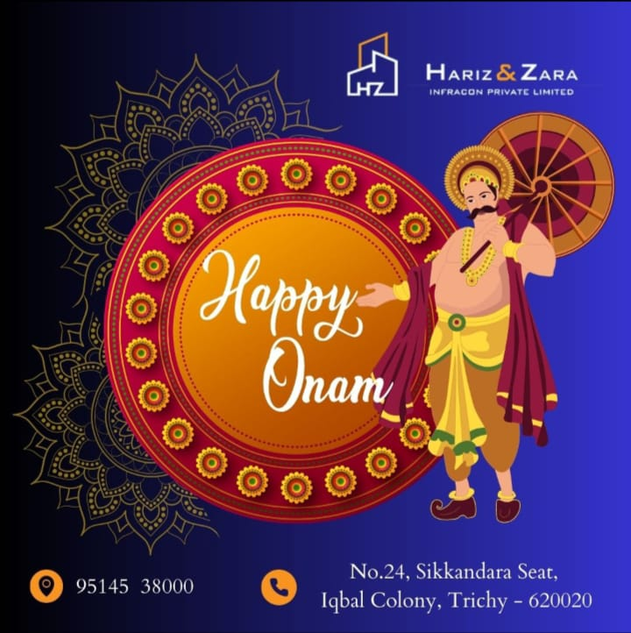

# TASK 2:

Create the advertisements for digi plus:



12

## PROJECT 1:

Create the advertisements for their clients:





13

# PROJECT 2:

Create a Wishes poster for clients:

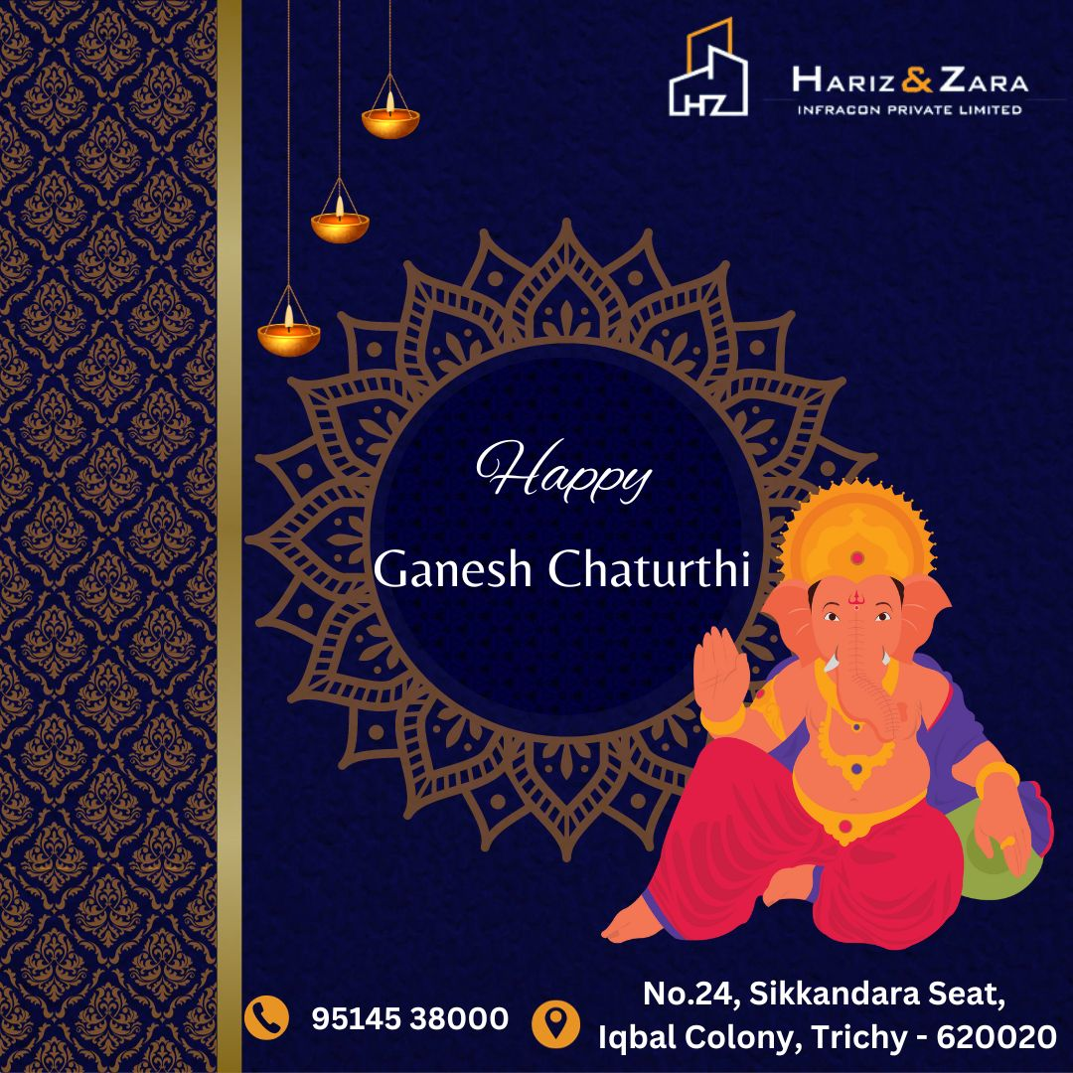

14

## PROJECT 3:

Create the advertisements for their clients:

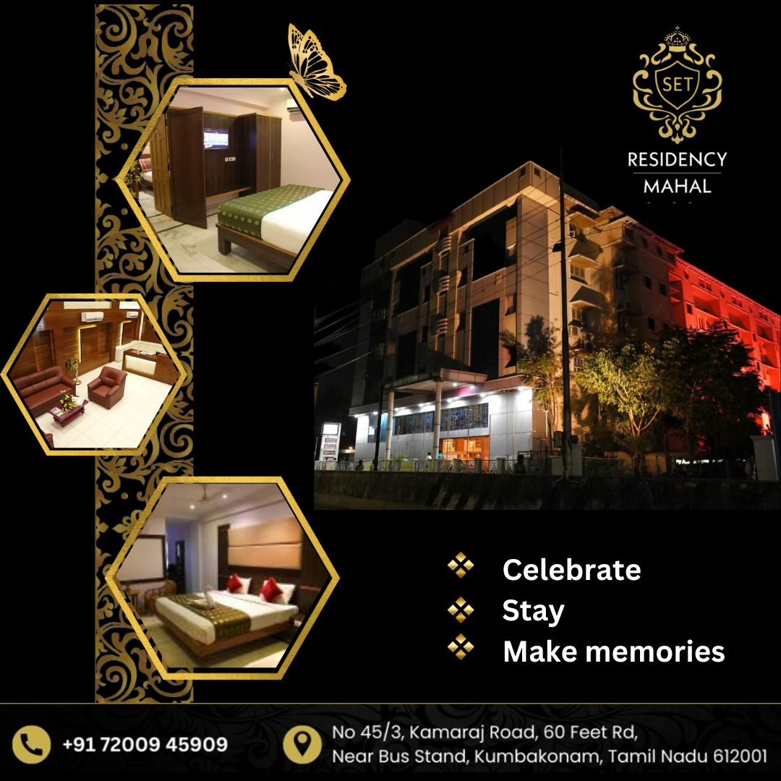

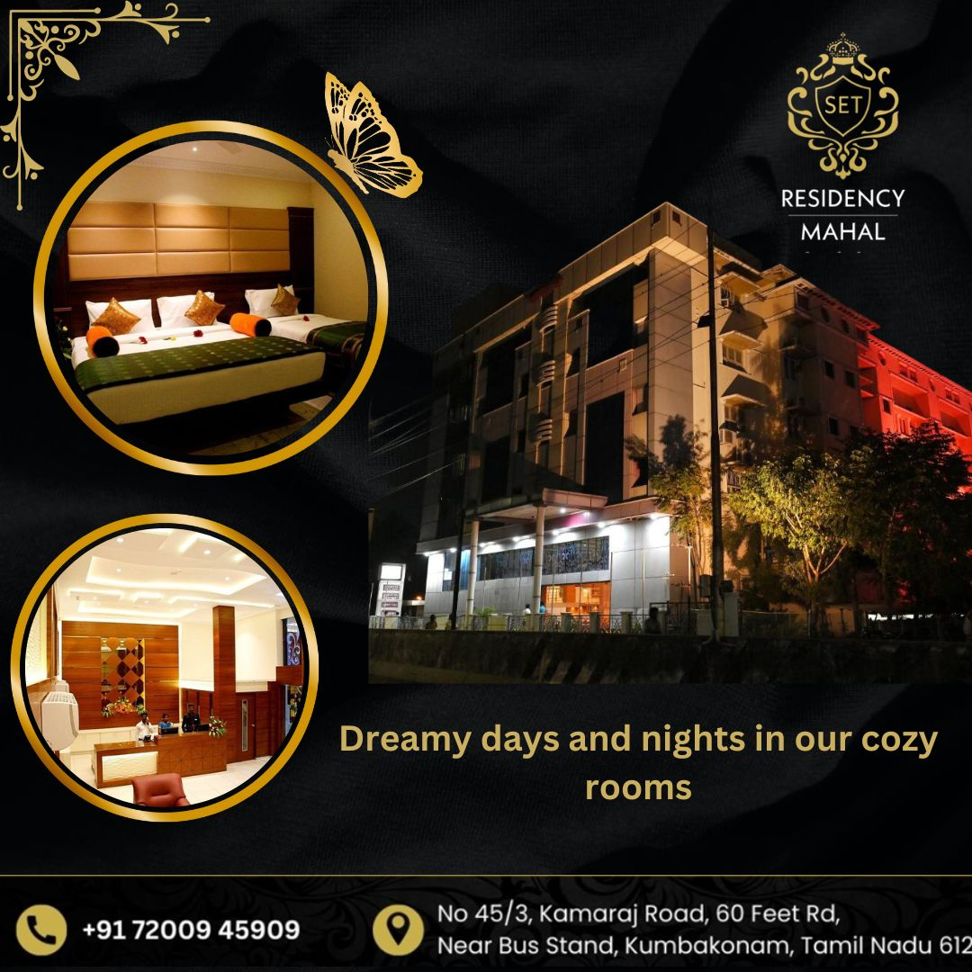

15

## PROJECT 4:

Create marketing templates for their clients:

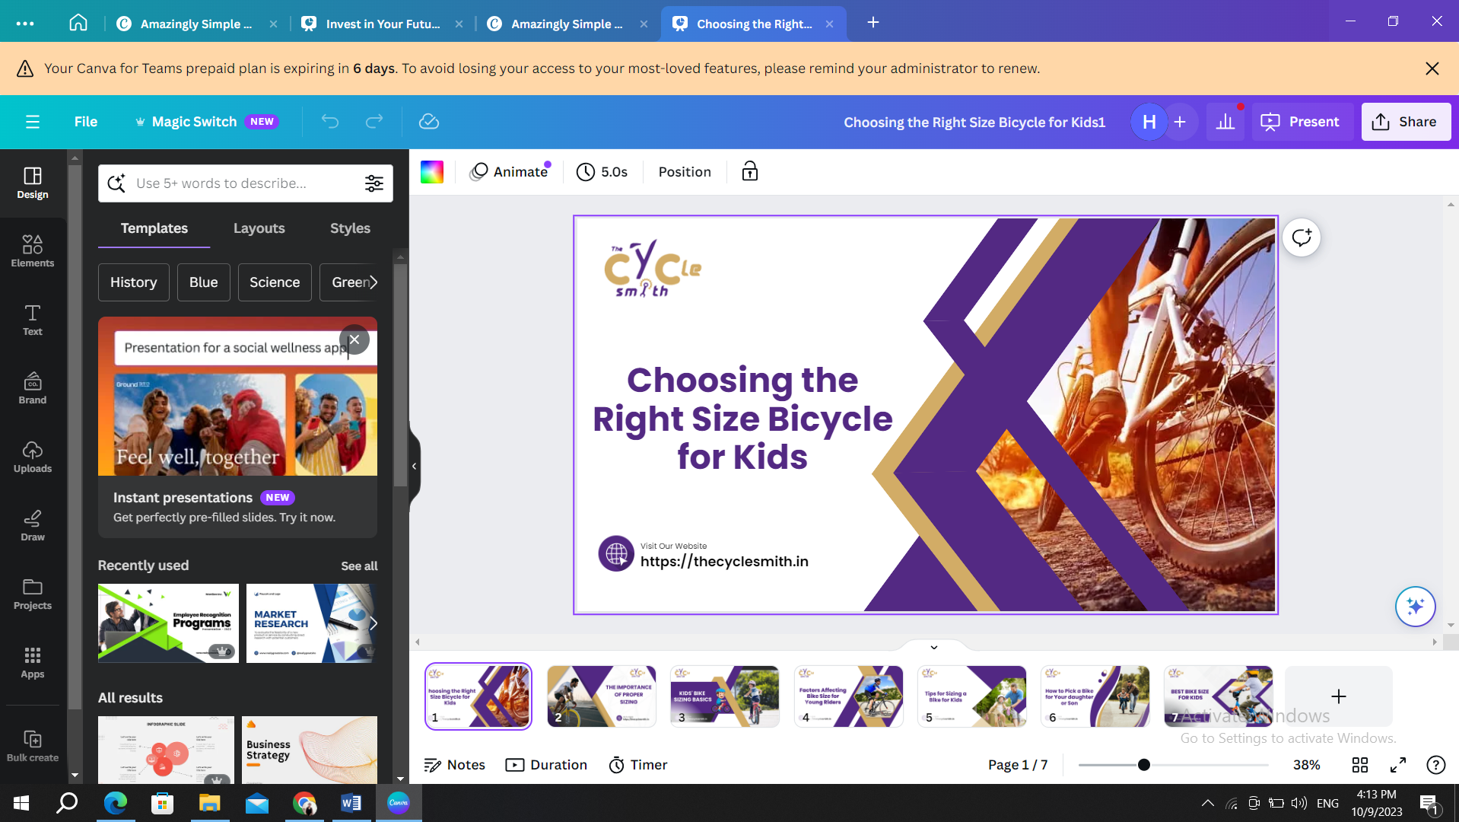

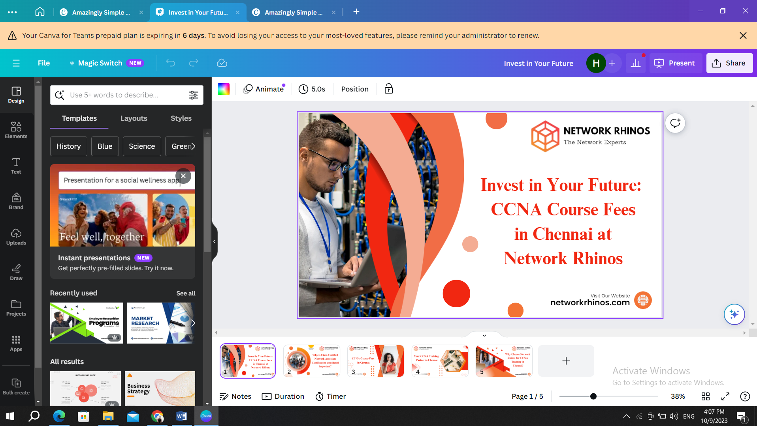

16

# VI. CONTRIBUTIONS AND ACCOMPLISHMENTS

**Contribution:**

I actively contributed in the company's creative projects throughout my graphic design internship, creating eye-catching materials like brochures, social media graphics, and brand collateral. My innovative ideas made it feasible to boost the business's marketing and draw in new clients. I worked well with the design team, contributing concepts and observations that raised the standard and significance of our work overall. demonstrated my ability to work under pressure by regularly meeting strict deadlines and making adjustments to project requirements. My proficiency with design software—more especially, Adobe Creative Suite—enabled me to generate high-quality outputs quickly. Along with actively working with clients, I made sure their goals and expectations were realized, which resulted in favorable comments and a continued collaboration. I encountered and overcome obstacles in design.

## Accomplishments:

Throughout the course of my internship in graphic design, I made a lot of noteworthy accomplishments that demonstrate my professional development and influence. Creating a poster for a well-known customer that not only satisfied their needs but also won acclaim from both the client and the creative team is one noteworthy accomplishment. I've also been acknowledged for my ability to work under duress because I regularly achieve strict project deadlines. I had the chance to spearhead the company's website redesign as part of a rebranding initiative, which produced a more contemporary and user-friendly online presence. This accomplishment greatly raised client engagement and the company's online reputation. Collectively, these accomplishments demonstrate my dedication, flexibility, and capacity to generate high-caliber project work during my internship.

# 

# 17

# VII. CONCLUSION

To put it succinctly, my path from a design student to a proactive and creative member of the professional world has been a transforming one in terms of my graphic design work. I developed my design abilities during this time, saw obstacles as chances for improvement, and actively contributed to the accomplishment of multiple projects. I take pride in my practical accomplishments, which include constructing websites, producing persuasive marketing materials, and receiving praise from peers and clients. My interest in graphic design has grown as a result of this internship. Along with the technical information I've acquired, I'm carrying with me priceless lessons in flexibility, time management, and teamwork. I can't wait to use these abilities and insights in my upcoming design projects.

18